Transmission Marketing

Copy:

Transmission is a science/arts event exploring the very real threat posed by antimicrobial resistance (AMR) to our future health. We are thrilled to be working once again with Professor Kevin Moffat from the University of Warwick, who collaborated with us during the creation of Tree in 2016. Kevin’s unstoppable energy for science is this time matched by a trio of brilliant minds from Coventry University Dr Phillip Gould, Dr Jess Rollason and Dr Lauren Acton, who will all be joining us in the rehearsal room to explore this important issue.

Transmission is a party with a difference, showing and sharing insights into infection, both viral and bacterial. An innovative mix of lecture, practical demonstration and dance, asking audiences to better understand the role of science in researching and combating AMR.

Dr Phillip Gould described the importance of the performance project’s theme, saying “Antimicrobial resistance is arguably the most serious global threat to human health in the 21st Century. Medicine has given more of us the privilege of, and indeed the disadvantages of, old age: age-onset diseases such as cancer, dementia and the need for surgical interventions. However, in a post-antibiotic era we risk reducing our chances of even growing old. We welcome back an age where even minor infections could prove fatal!
Over 500,000 people die worldwide every year from antibiotic resistant infections. The Government Health Secretary states "The UK has taken a global lead by setting out a 20-year AMR vision…we need an urgent global response’. This project will put Coventry at the centre stage in educating and raising public awareness to microbial disease transmission and the real threat of antimicrobial resistance within its culturally diverse community. This would impact directly upon the control of communicable disease, infection control and ultimately increase health and wellbeing within the city’s population.”

Transmission will immerse audiences 13+ in scientific research, using demonstrative dance exposing the art of getting ill. The event fuses research from both universities, with Highly Sprung’s use of physical theatre via dance to illustrate infection and control of illness-spread at a microbial level. Audiences are invited into a playful dialogue that sits somewhere between science and art, whilst at the same time participating in a mass experiment revealing the rapid spread of bacteria and viruses through human contact.

Tickets:

1.00pm – https://www.eventbrite.co.uk/e/transmission-tickets-62802308395

7.30pm – https://www.eventbrite.co.uk/e/transmission-tickets-63043079548

Social Media Posts:

Twitter
A collaboration with @HighlySprung, @covcampus & @WarwickLifeSci, Transmission is a science/arts event for age 13+ exploring the very real threat posed by antimicrobial resistance (AMR) to our future health on 15 July 2019, 7.30pm, Coventry. Free tickets: https://bit.ly/2wGlokD

Join @HighlySprung, @covcampus & @WarwickLifeSci for Transmission, an innovative mix of lecture, practical demonstration and dance, asking audiences to better understand the role of science in researching and combating AMR on 15 July, 7.30pm Free tickets: https://bit.ly/2wGlokD

Transmission will immerse audiences 13+ in scientific research, using demonstrative dance exposing the art of getting ill. Fusing research from @covcampus & @WarwickLifeSci, & @HighlySprung's use of physical theatre. 7.30pm 15 July, Coventry. Free tickets: https://bit.ly/2wGlokD

Facebook
Transmission is a science/arts event for age 13+ exploring the very real threat posed by antimicrobial resistance (AMR) to our future health, a collaboration with Highly Sprung Performance Co., Coventry University & the University of Warwick.

Transmission is a party with a difference, showing and sharing insights into infection, both viral and bacterial. An innovative mix of lecture, practical demonstration and dance, asking audiences to better understand the role of science in researching and combating AMR.

Join us on 15 July 2019, 7.30pm, Ellen Terry Theatre Coventry. Free tickets: https://bit.ly/2wGlokD

Email Copy (Schools):

We are writing to invite you and your students to a one off performance event bringing together performance and science.
Designed to immerse audiences into the world of viruses and bacteria, the performance opens up debate around the use of antibiotics and what happens when diseases no longer respond to the drugs designed to kill them.
Exploring Anti-Microbial Resistance, now recognised as one of the most serious global threats to human health in the 21st century, the performance is FREE and suited to any student 13+ with an interest in science or performance.
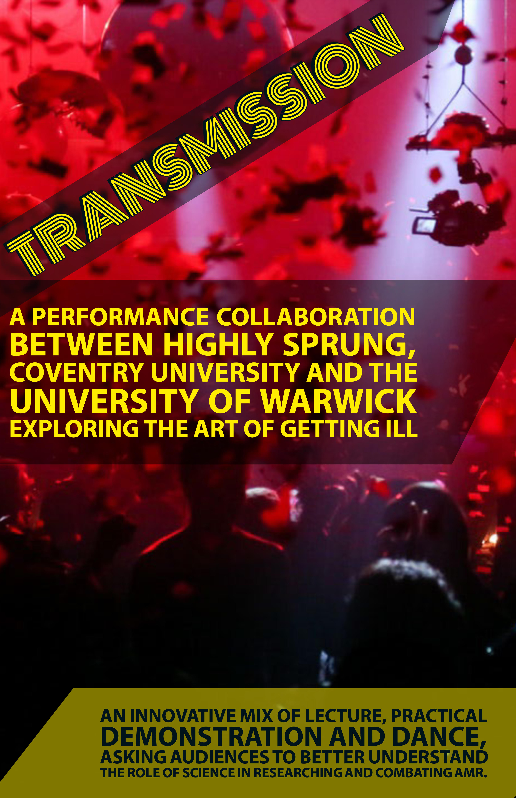
For more information or to book tickets:
The event is free.
Location: Ellen Terry Theatre, Coventry University, Coventry, West Midlands, CV1 5RW
Tickets available at:
https://www.eventbrite.co.uk/e/transmission-tickets-62802308395
Or for more information please contact Sarah:
sarah@highlysprungperformance.co.uk
07810263355
Email Copy (Public):

We are writing to invite you to a one off performance event bringing together performance and science.
Designed to immerse audiences into the world of viruses and bacteria, the performance opens up debate around the use of antibiotics and what happens when diseases no longer respond to the drugs designed to kill them.
Exploring Anti-Microbial Resistance, now recognised as one of the most serious global threats to human health in the 21st century, the performance is FREE and suited to anyone aged13+ with an interest in science or performance.
For more information or to book tickets:
The event is free.
Location: Ellen Terry Theatre, Coventry University, Coventry, West Midlands, CV1 5RW
Tickets available at:
https://www.eventbrite.co.uk/e/transmission-tickets-63043079548
Or for more information please contact Sarah:
sarah@highlysprungperformance.co.uk
07810263355

