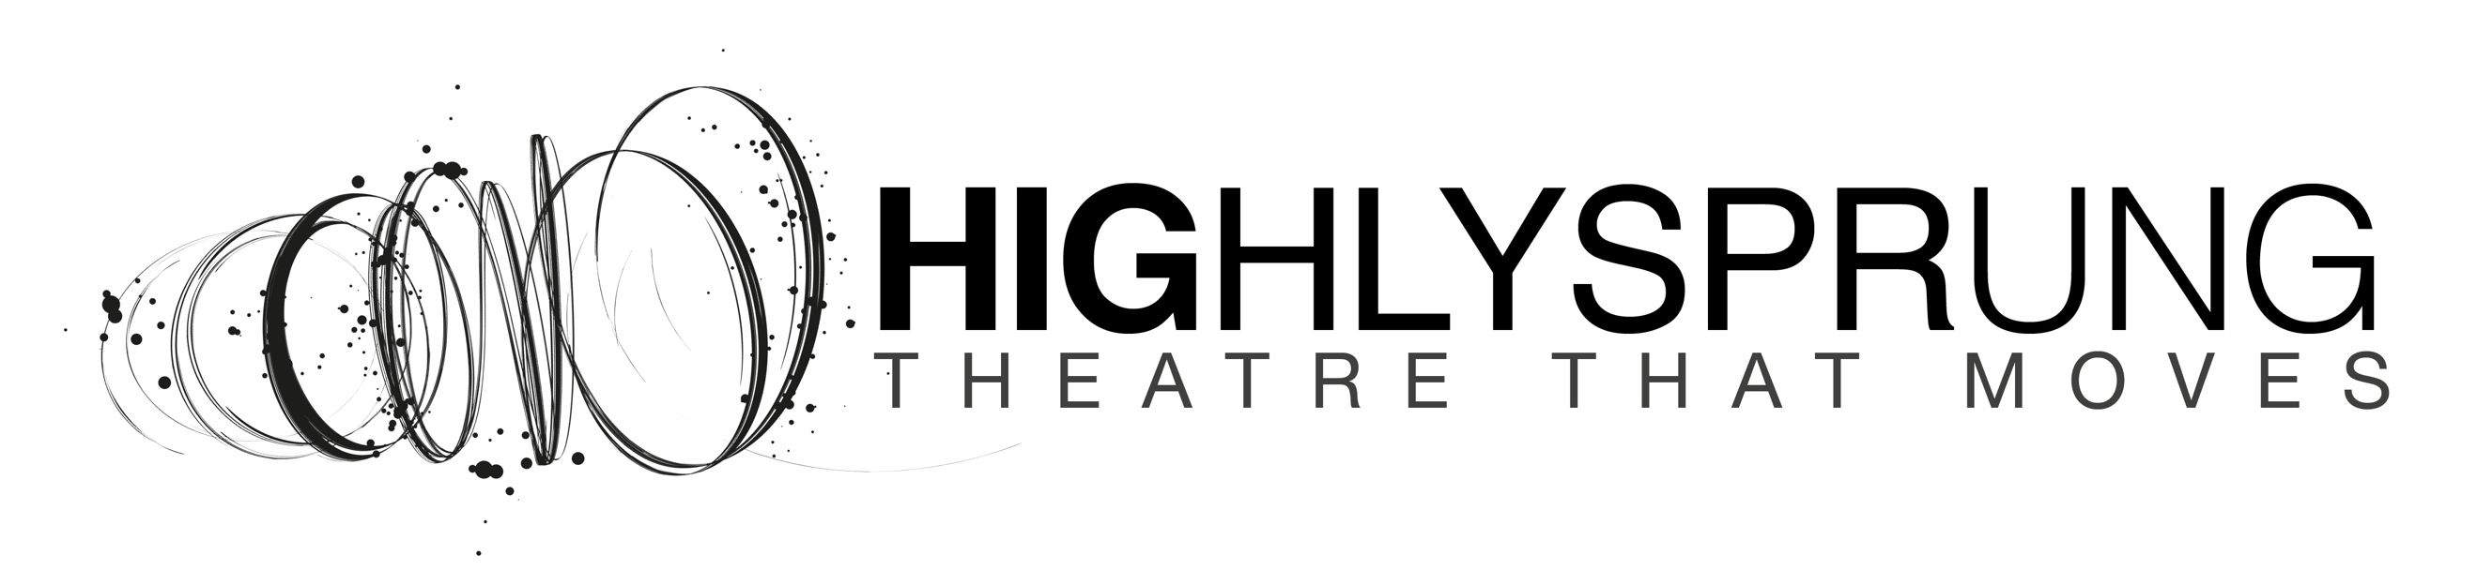
Up, Up and Away
Press Release
September 2019

Highly Sprung’s Up, Up and Away

Award-winning physical theatre company Highly Sprung is performing Up, Up and Away at [venue] on [date] as part of its Autumn 2019 UK tour.

Up, Up and Away is a cloud-hopping, star-jumping, stratospheric adventure for children and young people using Highly Sprung’s unique mix of movement theatre, aerial dance and innovative design to tell a story that is literally out of this world.

Offered the chance to float up and away into the sky on a large red balloon, Jo doesn’t hesitate. On Earth he’s called “different”; misunderstood by everyone, including his family. Exciting adventures and new friends await Jo in the clouds, where everyone is different. Embarking on series of adventures, Jo learns how being different is special and wonderful; more than he ever imagined.
Up, Up and Away is written and performed by Highly Sprung: the UK’s leading physical theatre company working exclusively with young people. Up, Up and Away draws on Highly Sprung’s extensive experience of working with children, using movement and drama to engage audiences in more immersive, creative experiences. Up, Up and Away is designed to engage children through a positive, engaging and high-quality arts experience, that promotes the joy of the arts.
Sarah Worth, Artistic Director said:
“Like so many children with special educational needs, Jo struggles to find a place for himself in everyday life. Up, Up and Away was devised to give all children the chance to recognise and delight in the differences they see in themselves and in others as they grow up in a world where ‘normal’ no longer applies. Exploring communication, social interaction and feelings of isolation, Up, Up and Away is a story for all children who see the world ‘differently’.”

For audiences of children aged 4+ and their families.

Autumn 2019 Tour dates:
Saturday 19 October Dance City, Newcastle Upon Tyne
Wednesday 23 October The Old Rep Theatre, Birmingham
Wednesday 30 October CAST, Doncaster
Saturday 2 November The Point, Eastleigh
Wednesday 6 November Forest Arts Centre, Walsall

Reviews
“Leaving every child feeling treasured and with a beautiful moral to the story, it will awaken the magic in everyone.”
★★★★★ The Reviews Hub

“A truly unique experience, this is a perfect treat for families.”
Families Online

“The atmosphere! Kids have never experienced anything like this ever!
“We loved all of it! You don’t just watch it – you live it and feel it too. And the interactive elements are wonderful.”
Audience members

For more information and high res production images please contact:

Sarah Worth, Director, Highly Sprung
sarah@highlysprungperformance.co.uk
07810 263355

NOTES TO EDITORS:

Credits for Up, Up and Away

Writer - Mark Worth, Highly Sprung
Director - Sarah Worth, Highly Sprung
Dramaturg - Nikky Smedley, How to Speak Child Productions
Design - Vortex Creates
Lighting and Projection - Arnim Friess, Highly Sprung

About Highly Sprung

Highly Sprung is the UK’s leading physical theatre company working exclusively for and with children and young people.

We create award-winning outdoor and indoor performances that tell stories through movement, gesture and dance. Stories that are inspired by humanity, science, and the complex world around us.

Using our own physical theatre techniques, we empower young people to explore how their bodies can be used to develop their own unique performing style. Every piece we make is original and devised by young people and our core team of artists and writers.

As well as touring work, we run weekly performance workshops for children and young people, and projects in primary and secondary schools across the UK and internationally. We also lead the UK’s only Physical Theatre Fellowship programme for emerging artists.

http://www.highlysprungperformance.co.uk
@HighlySprung

