Highly Sprung
Associate Artist Application Pack
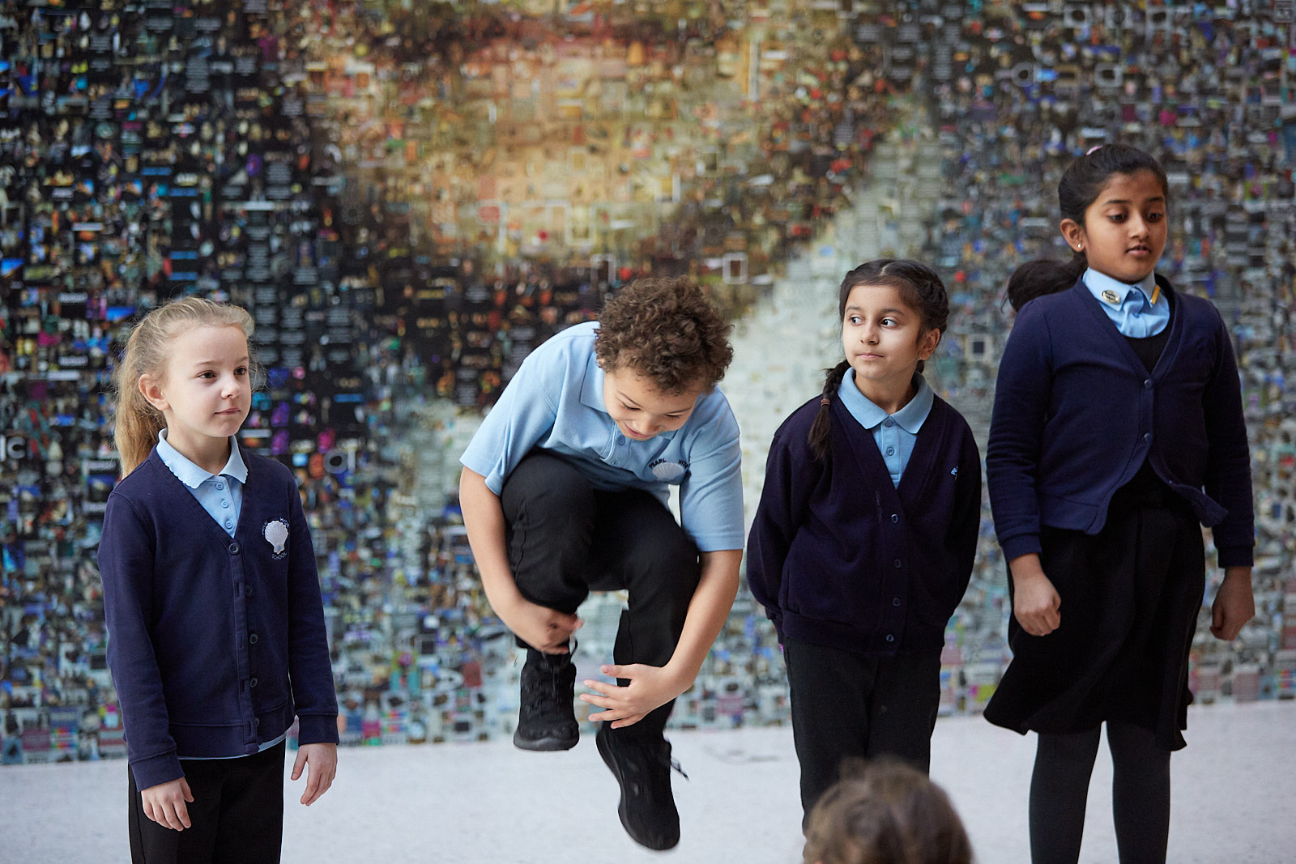

If you require this pack in an alternative format or need any additional support in making an application, please contact us on:
07810263355 or email team@highlysprungperformance.co.uk.

Contents:
- About Highly Sprung
- Job Description
- Person Specification
- How to apply

Highly Sprung

Highly Sprung creates physical theatre that empowers young people make sense of themselves and the world around them. Using movement to tell stories when words won’t do.

Theatre that challenges them to explore and express their unique creativity and identity; to discover their own voice.

Theatre that is brave, extraordinary, and uncompromisingly beautiful.
​
Founded in Coventry in 2000, we work nationally and internationally providing opportunities and experiences that captivate audiences and champion more than 10,000 young people every year.

Highly Sprung have a strong reputation in the delivery of work with, for and alongside children and young people, that inspires creativity and develops the use of physical performance. Highly Sprung offer a range of projects annually that give children and young people opportunities to engage with the charity in physical performance and creative education.

The Role

Thanks to funding provided by DCMS and Arts Council England, Highly Sprung are looking for five exceptional people to extend their pool of experienced Associate Artists with physical theatre or dance theatre expertise.

These five new roles are an opportunity for Highly Sprung to meet and work with talented artists with a passion for creative learning. To train with us and work closely with our existing team to deliver inspiring participatory projects in a range of settings throughout the year.

If successful with this application, you will join Highly Sprung for a for a four-day Associate Artist training residency from Tue 8th to Fri 11th June 2021.

The residency will be an insight into Highly Sprung’s creative education processes and will focus on embodied learning, exploring our style and practice and how we apply this in both performance and education contexts with children and young people age 4-21.

We welcome applications to join us for this training opportunity from performers with experience working with children and young people in and outside of education.

Associate Artists will have experience in and be committed to delivering high-quality participatory arts activities for children and young people. They have the artistry and understanding to make work using physical theatre approaches. Highly Sprung Associate Artists are passionate champions for children and young people, they are excellent role models who empower participants to find their own voice and they use it to make inspiring work.

The successful applicants will be required to work mainly in the Midlands, but at times in various locations across the UK and will need to undertake a full DBS check.

We are specifically looking to increase representation across our delivery team, to better meet the needs of the audiences, children, and young people we work with. We acknowledge that people from Black, Asian, and Ethnically Diverse backgrounds are currently under-represented in our team and particularly encourage applications from these groups.

Highly Sprung are committed to equal opportunities.

Fee

£100/day x4 days for training residency Tue 8th to Fri 11th June 2021
Plus: expenses for travel and accommodation costs for Associate Artists living 15 miles from the charity base (CV1) as per our expense policy.

Hours of work: 10am-5pm
Maximum of 40 hours per week, which may involve evening and weekend work and travel away from home.

Job Description

Highly Sprung has a commitment to developing new diverse audiences and making work more accessible through an extensive community and education programme and touring of performances using physical performance. The Associate Artist role is vital in making this work happen.

The Associate Artist is an artist and educator who delivers creative physical performance processes as part of Highly Sprung’s activities.

Responsibilities include:
- Planning and delivering a range of physical performance projects and workshops as part of Highly Sprung’s artistic programme.
- To effectively plan and liaise with Highly Sprung’s Directors and any other team members or partners connected to with the Associate Artist’s work with the Highly Sprung.
- To plan, create, organise, and participate in performance events, which give children and young people the opportunity to share the outcomes of their work with, peers, public, and parents/family.
- To lead sessions with enthusiasm and commitment and to promote a positive and inclusive working atmosphere. To engage with children and young people in an inspiring and accessible way to develop their creativity.
- To undertake regular evaluation and reflection processes individually and as a member of a team to develop practice and approaches to creativity.
- To work competently as an individual artist or as a team of artists delivering a project/workshop.
- To comply with Highly Sprung’s Safeguarding Policy, Equal Opportunities Policy, and other charity policies at all times when representing Highly Sprung.

Person Specification

The Associate Artist is a professional artist with training and experience in dance/drama and physical theatre and will have a knowledge and experience of creative teaching practice.

Essential skills:
- Relevant experience or training in theatre/dance or creative education practice.
- Experience of physical theatre-making.
- A commitment to diversity and inclusion, engaging young people and communities from all backgrounds in the arts.
- Experience of running theatre workshops with young people.
- Excellent communication skills and a positive, friendly, and professional attitude.
- Strong personal organisation skills.
- Ability to work on your own initiative and as part of a small, committed team.
- To have relevant experience of using dance/drama and physical theatre to access a wide range of topics.
- To have a clear and relevant understanding of the wider context of both local and national arts and creativity related issues and movements.

Desirable skills
- Choreography/direction, making your own performance work.
- Some understanding of safeguarding practice.
- Some understanding of creative and embodied approaches to education.

How to Apply

Make sure you have considered the role and understand your suitability for it.

Familiarise yourself with the work of Highly Sprung, especially in creative education and learning by visiting the website:
www.highlysprungperformance.co.uk

To apply for this opportunity, you will need to submit the following:

A relevant CV.

An up-to-date head shot, so we can identity check you at interview stage.

A short expression of interest, which includes the following:
- 3 words that best describe you
- An outline of your relevant experience
- Your reasons for wanting the role
- What you will bring to the work of Highly Sprung
- One reference- character or professional

Equal Opportunities form – please fill this out online here.

Please review the job description and person specification carefully to ensure you have the relevant skills and experience before applying.

Please send your application to Highly Sprung over email with ASSOCIATE ARTIST APPLICATION in the subject line.

Email to: team@highlysprungperformance.co.uk

If you have any access issues, please contact: sarah@highlysprungperformance.co.uk.

If you cannot email, please post to:
HIGHLY SPRUNG
Daimler Powerhouse, Sandy Lane Business Park
Sandy Lane
Coventry
CV1 4DQ

Deadline for applications is Monday 24th May at 5pm.
Applications arriving after this date will not be considered.

Shortlisted applicants for the interview stage will be notified by email no later than Wednesday 26th May.

Interview
Shortlisted candidates will be invited to a 30-minute interview with Highly Sprung’s directors.
Interviews will be held online on either 27th or 28th May from 10:30am-3:30pm.
The interview will invite candidates to present a response to a creative brief, answer questions about their own experience and practice and understand what they would bring to the role of Associate Artist with Highly Sprung.

Offers
All offers will be made subject to receipt of satisfactory references, proof of identity, address, and eligibility to work in the UK. You will be required to undertake an enhanced DBS check.

Highly Sprung Team

Executive Director Sarah Worth
Artistic Director Mark Worth

Senior Associate Artist and Emily Robertson
Schools Development Co-ordinator

General Administrator Cheryl Revill
Project Administrator Zoe Drinkwater

Trainee Associate Artist Jade Hicks

Marketing and Comms Assistant Hayley Salter

Producer Phil Hargreaves

Board
Claire Singleton (Chair), Amanda Campbell, Tony Carroll, Jo Trowsdale, Trish Willetts.

If you need any further help or guidance please do get in touch,
we look forward to hearing from you.

